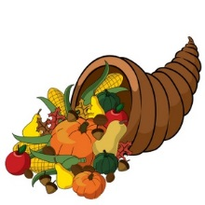 Annual Thanksgiving Lunch
Please join PSE for a Thanksgiving Lunch for our students and family

Tuesday, November 17th Wednesday, November 18th
Kindergarten 10:30 am – 11:16 am 4th grade 10:41 am – 11:25 am
1st grade 11:13 am – 11:59 am 2nd grade 11:25 am – 12:16 pm
3rd grade 11:56 am – 12:42 pm 5th grade 12:08 pm – 12:59 pm

The schedule listed above is the block of lunch time for that grade level. Your specific teacher and lunch time are the following:
Teacher: __________________________
Lunch Time: ________________________
***Menu***
Turkey, Gravy and Dressing or Popcorn Chicken
Cranberry Sauce, Sweet Potato Soufflé with marshmallow topping, Garlic Mashed Potatoes, Green Beans, Fruit Candy Corn Cup, Apple Crisp, Fresh Fruit
Lunch $3.50
Please note the entrée choice on November 18th will be Corn Dogs instead of Popcorn Chicken

Please return the bottom portion and place in the Thanksgiving box by November 12, 2015 located in the front lobby
---------------------------------------------------------------------------------------------------------------

Student Name: _______________________________ Teacher: _____________________
Grade: _________ Number of guests attending lunch: ____________

